Project Design Phase-II
Data Flow Diagram & User Stories

Date | 08-12-2025
Team ID
Project Name | Book Doctor
Maximum Marks | 4 Marks

Data Flow Diagrams:
A Data Flow Diagram (DFD) illustrates how data moves within the Book a Doctor platform. It captures how users (User and Doctor) interact with the system, how information flows between different components, and where the data is stored.

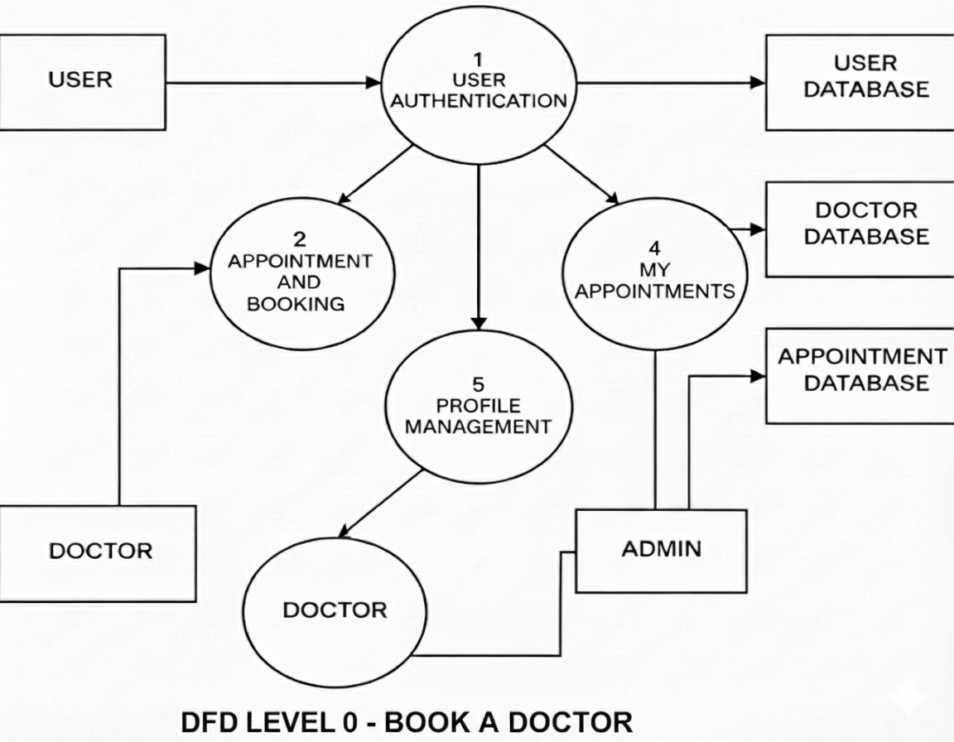

User Stories
User Story Table – Freelance Finder

User Type | Functional Requirement (Epic) | User Story / Task | Acceptance Criteria | Priority | Release
user | Appointment Booking | As a user, I can search for a doctor based on specialty, location, or availability. | Search results show relevant doctors with available time slots. | high | Sprint-1
User | Appointment Booking | As a user, I can book an available appointment slot with a doctor | A confirmation is received, and the appointment appears in my 'My Appointments' section. | Medium | Sprint -2
Doctor | Appointment Management | As a doctor, I can view and manage my schedule and accepted appointments. | Filter allows viewing appointments by date, status, or user. | High | Sprint-1
User | Appointment Management | As a user, I can cancel or reschedule an existing appointment. | Cancellation/rescheduling is confirmed, and the doctor is notified. | Medium | Sprint-2
Doctor | Profile Management | As a doctor, I can update my profile details, including specialty, availability, and consultation fees. | Changes are immediately reflected in search results for users. | High | Sprint-2
Admin | User Moderation | As an admin, I can view and manage reported doctor/user profiles and take appropriate action. | All reports and actions are logged and accessible in the admin dashboard. | High | Sprint-1

